My Deep Learning Journey

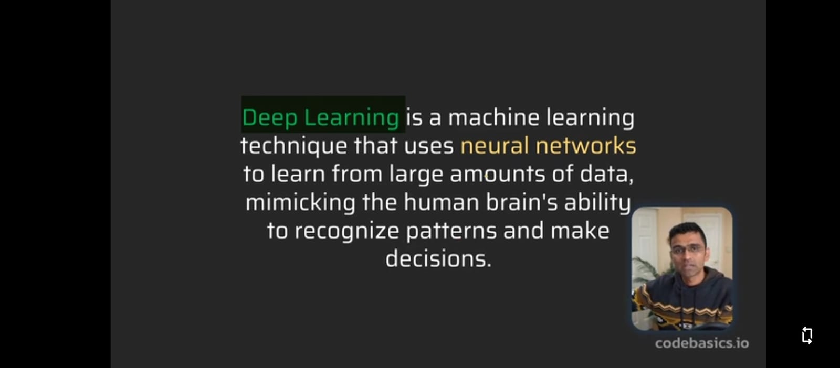

When to use

Deep Learning Architecture

## What is Neuron

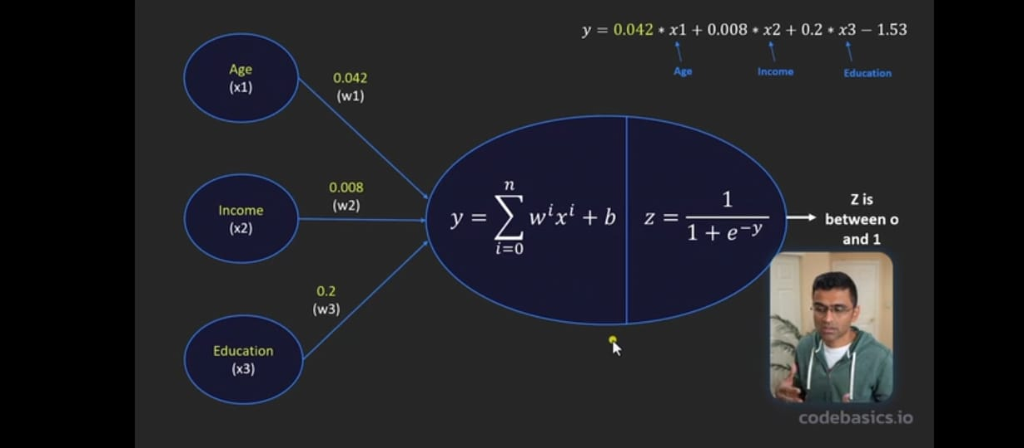

A complete unit that take input apply processing and give output

## What is Perceptron

It is most simplified form of a neuron and it’s activation function is step function

## Multi Layered Perceptron or Multi layered Neuron

* It’s a **network of many neurons organized in multiple layers**:
  + Input layer (just passes input),
  + One or more **hidden layers** (each with multiple neurons),
  + Output layer.
* Each neuron in one layer connects to **all neurons** in the next layer.

**Simple Neuron:**

inputs → [neuron] → output

**MLP:**

inputs → [layer 1: many neurons] → [layer 2: many neurons] → output layer

## Intution of Neural Networks

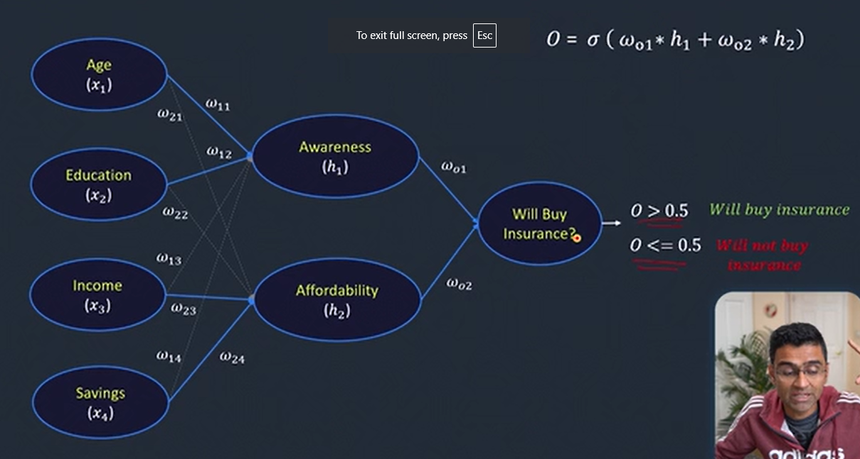

## Activation Function

**Why we need** because we have to introduce no linearity in some cases like in the logistic regression

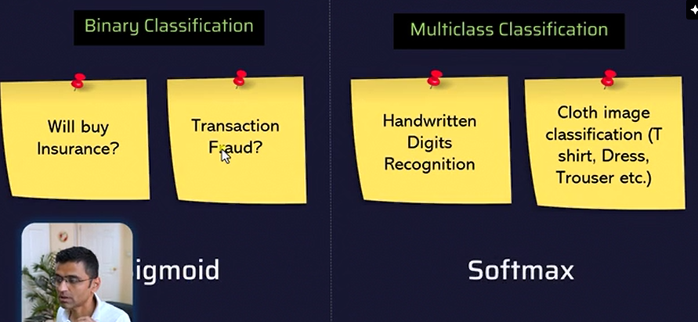

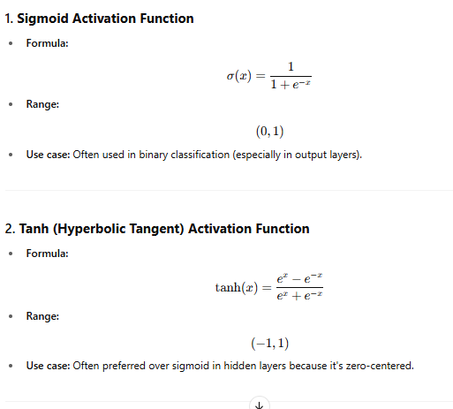

Soft make converts input into porbablities so that sum of all the probabilities is 1

Issue with the sigmoid and tanh

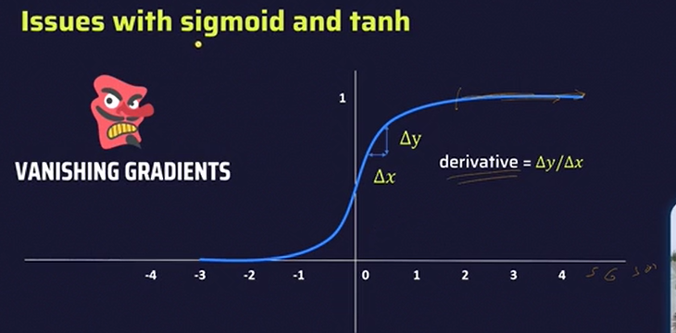

At some point the derivative can no be findable because slope become stariht line like at position 10000

Thus it cannot be used in the hidden layer but can be used in output layers

To solve this problem **ReLu (z)** come in the hidden layer because

To Solve the problem of dead neuron

